13. How to Attach a Photograph / Supporting Document to a Support Plan

If a photograph or supporting document has already been uploaded into Nourish this will be shown in ‘Documents’, under the ‘Profile’ section.

To view the ‘Documents’ section, please follow the below steps.

- Select the resident you would like to view

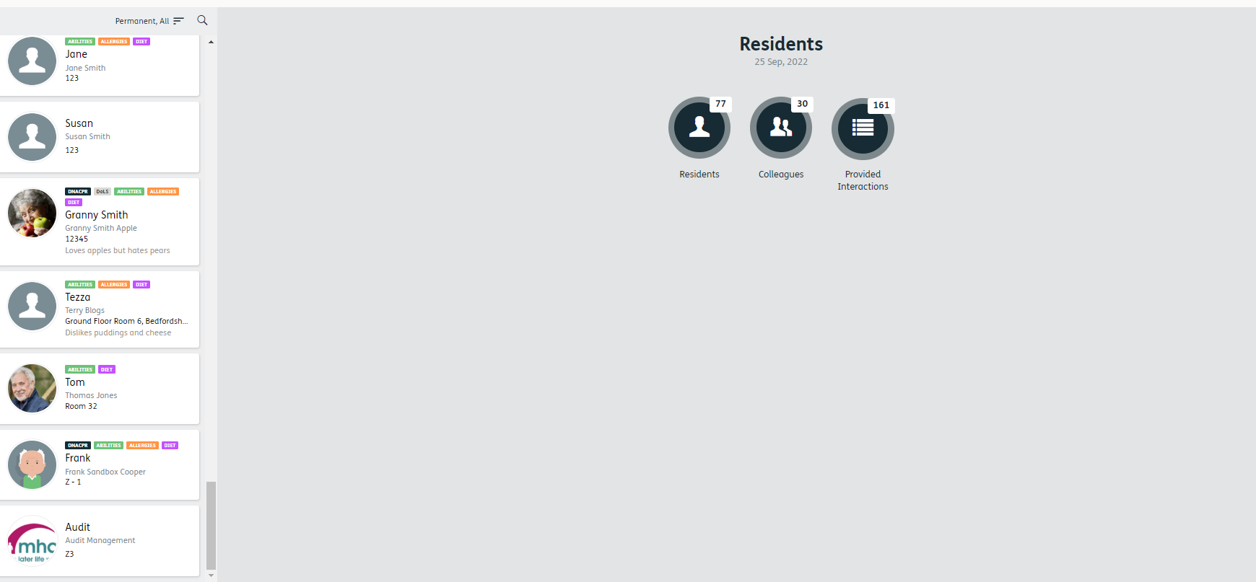

1.

- Select ‘Profile’
2.
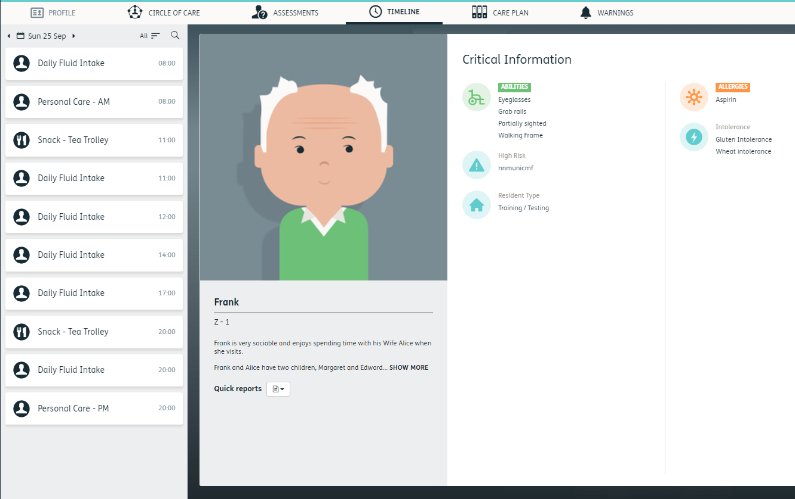

- Select ‘Documents’

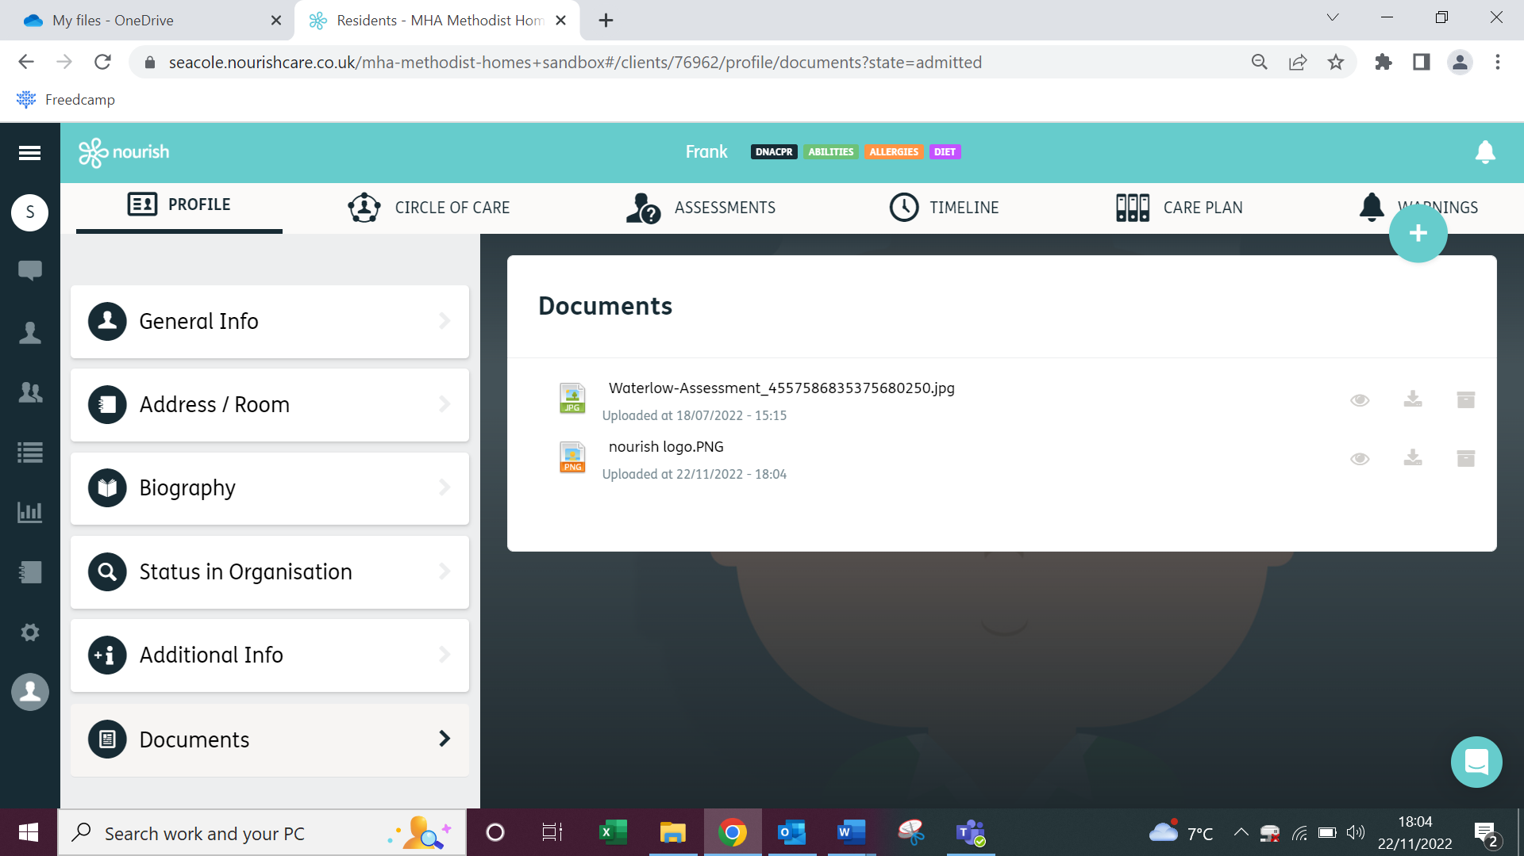
3.

3.

On the right, in the box, you will see all photographs and supporting documents which have been uploaded into Nourish. To attach to a support plan you must first download this onto your PC / laptop.

- Click on the ‘download’ icon

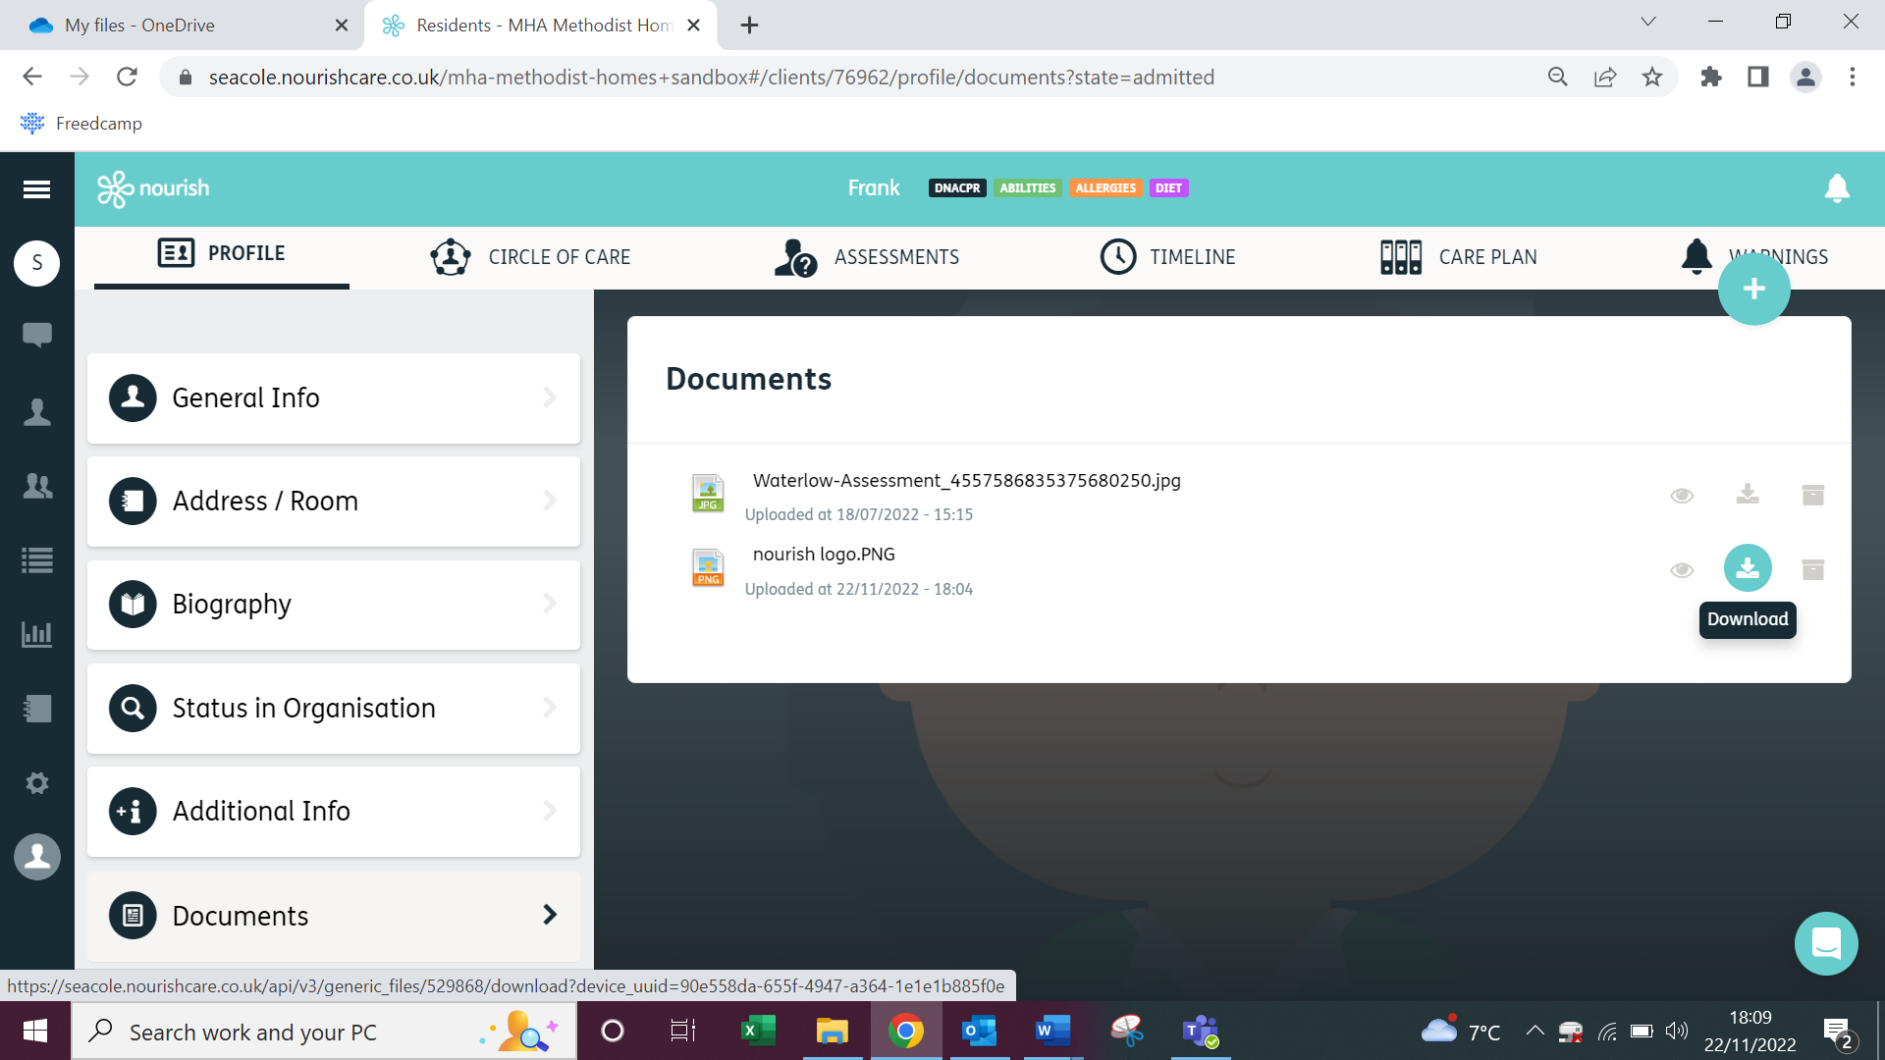
4.

This will download a copy onto your device for you to save where you choose. Downloaded documents are autosaved to the ‘downloads’ section of your folders.

To attach it to a Support Plan you must first go to the Care Plan section.

- Select Care Plan from the top bar
5.



- Select the Support Plan you wish to attach the photograph / document to –

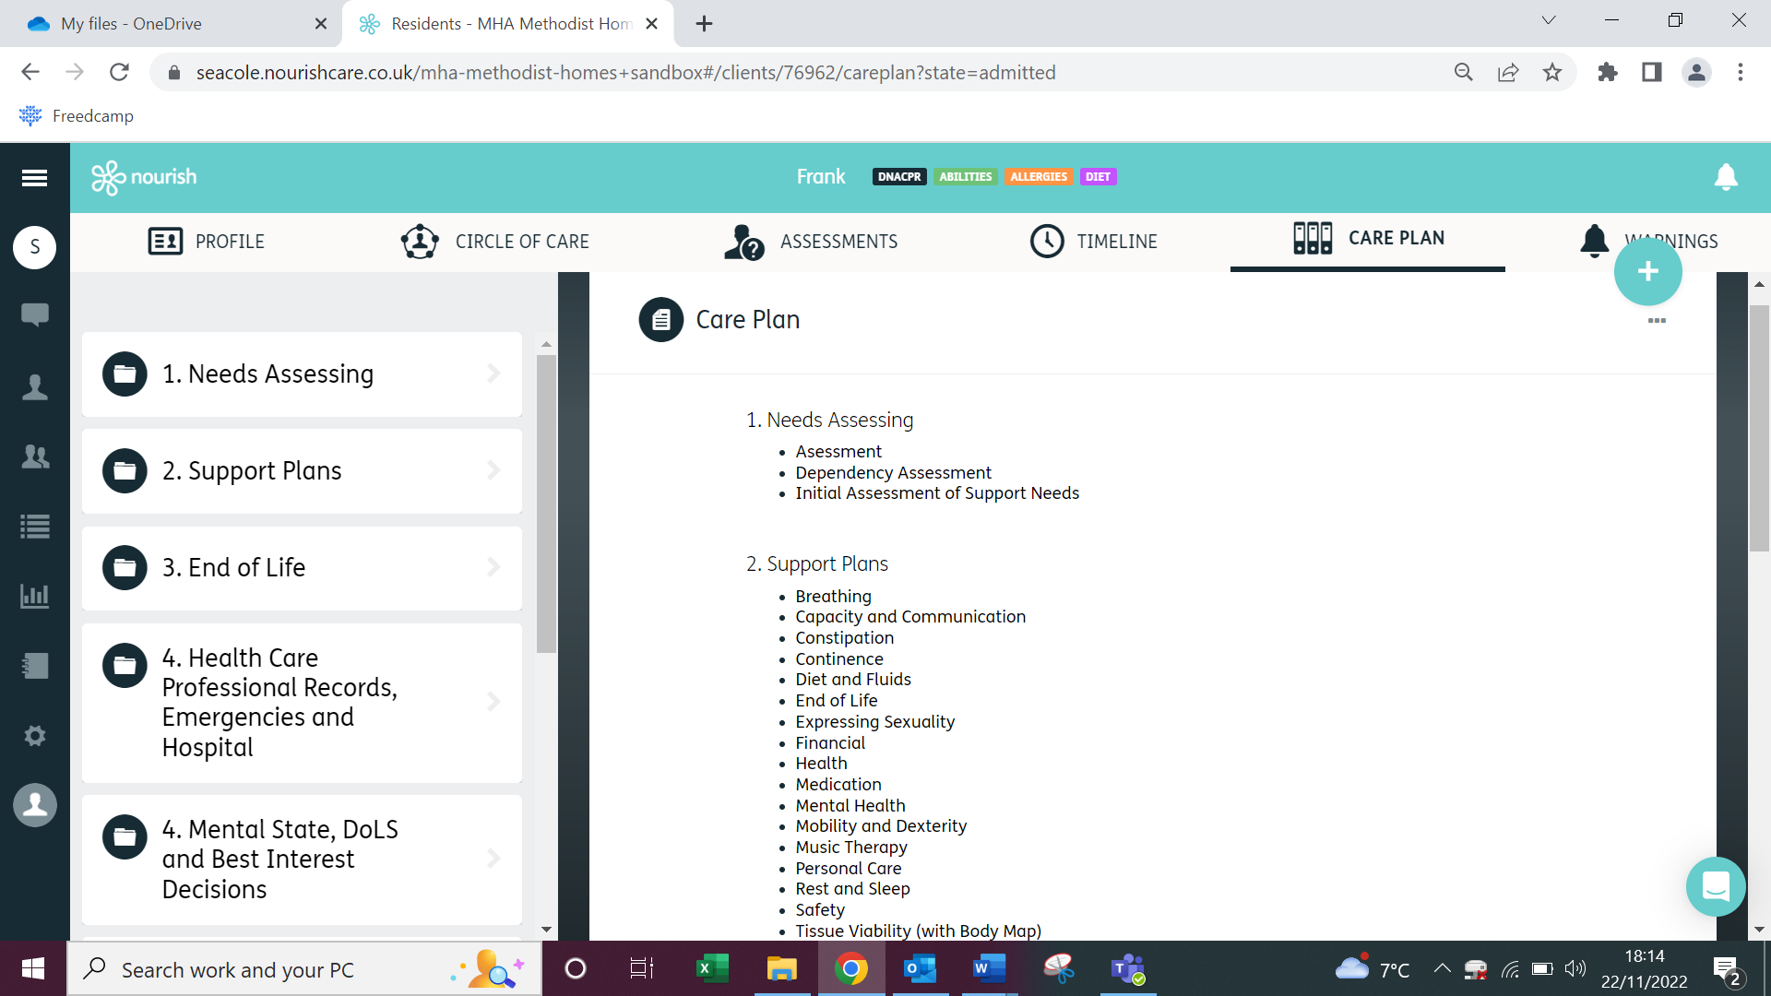
6.
v

- Click on the ‘Blue Plus’

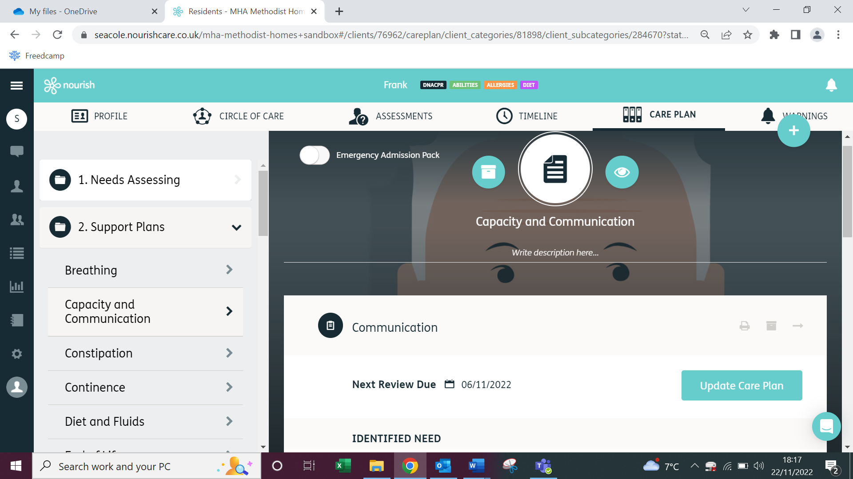
7.

- Click on the 5th option down ‘Document’

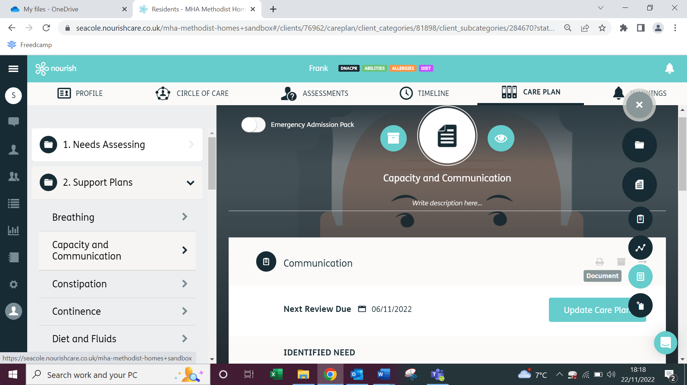
8.

A box will pop up with your folders. Select the photograph / supporting document you wish to download.

- Select your photograph or supporting document and double click
9.

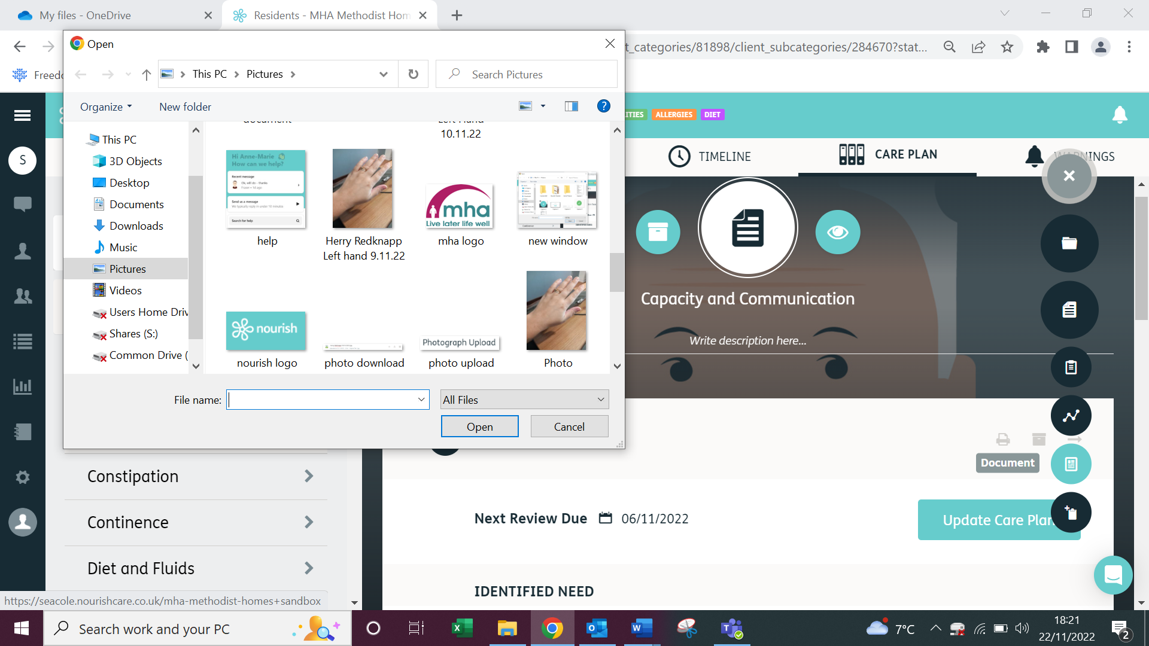

A message should appear to say ‘File uploaded successfully’

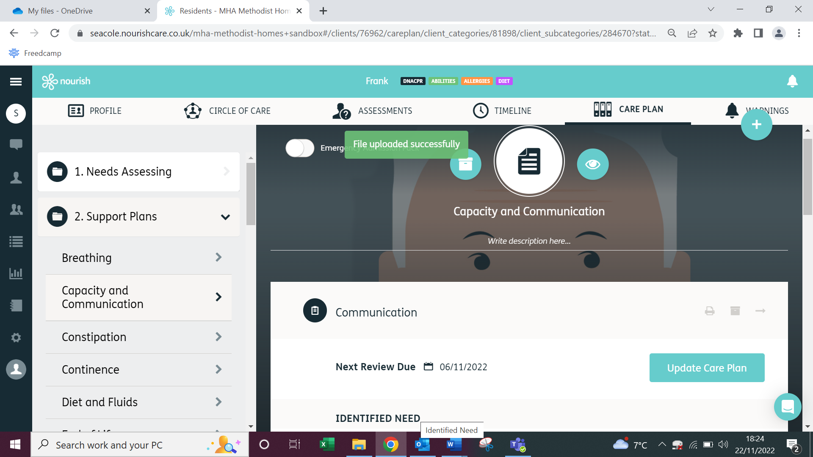

The photograph / supporting document will then be available to view in the ‘Documents’ section at the bottom of the support plan -

